# Predicate Logic

* The connectives ~, ∧, ∨, =>, and <=> are not enough to prove or disprove all types of logical statements.
* For example:
* All UOW math courses are fun,
* Math 221 is a UOW math course,
* Therefore, Math 221 is fun.
* This is correct, but we cannot determine its validity with the tools we have so far.
* We need to be able to manage words such as “all” and “some.”
* **Predicate:** a sentence that contains a finite number of variables and becomes a statement when values are substituted.
* The **domain** of a variable is the set of all possible values it can be.
* The **truth set** is the subset of the domain that makes the predicate true.
* Predicates of one value are denoted: **p(x)**, **q(x)**
* Notation:

|  |  |  |
| --- | --- | --- |
| Symbol | Name | Example |
| ℝ | Set of all **real numbers** | Can be integers, fractions, etc… |
| ℚ | Set of all **rational numbers** | Can be written as a fraction. |
| ℤ | Set of **integers** | Whole numbers … -2, -1, 0, 1, 2, … |
| ℕ | Set of **natural numbers** | Counting numbers … 1, 2, 3, … |
| ∈ | **Contention** | “Is contained in,” “belongs to,” “is a member of…” |
| ∀ | **Universal quantifier** | “For all” |
| ∃ | **Existential quantifier** | “There exists” |
| ∋ | **Such that** |  |

Exercise:

The predicate p(x): “x is a positive integer strictly less than 5” with dom­p = ℤ has truth set {…, -2, -1, 0, 1, 2, 3, 4}.



Exercise:

The predicate q(x): “x2 > x” with domq = ℝ has truth set.



## The Universal Quantifier ∀

* One way to change a predicate into a statement is to assign values to the variables.
* Another way is to add quantifiers.

Exercise:

1. “All humans are mortal.”
2. “All real numbers have a nonnegative square.”



* **Universal statement:** has the form, **∀** x ∈ D, p(x).
* It is true IFF (if and only if) p(x) is true for every x ∈ D if at least one x ∈ D can be found that makes p(x) false, the statement is false.
* Such an x is called a counterexample (contrapositive).

Exercise:

∀ x ∈ ℝ, x2 > x.



Exercise:

Write using **∀**.

1. All dogs are animals
2. Every integer greater than zero has a prime factor.



Exercise:

Let D = {1, 2, 3, 4, 5}.

1. Show that the statement **∀** x ∈ D, x2 ≥ x is true.
2. Show that the statement x ∈ D, is false.



## The Existential Quantifier ∃

Exercise:

1. “There is a cat in my house.”
2. “There are integers m and n such that m + n = mn.”



* **Existential statement:** has the form ∃ x ∈ D ∋ p(x).
* It is true IFF (if and only if) p(x) is true for at least one x ∈ D.
* It is false IFF p(x) is false for all x ∈ D.

Exercise:

Write using ∃.

1. There exists a real number whose square is negative.
2. Some person is a vegetarian.



Exercise:

Show that the statement “∃ m ∈ ℤ ∋ m2 = m” is true.



Exercise:

Let E = {5, 6, …, 10}. Show that the statement ““∃ m ∈ E ∋ m2 = m” is false.



Exercise:

Rewrite using informal language.

1. **∀** x ∈ ℝ, x2 ≥ 0
2. ∃ m ∈ ℤ ∋ m2 = m
3. **∀** Students s, ∃ Math subject y ∋ s likes y
4. **∀** x ∈ ℝ, x2 ≠ -1

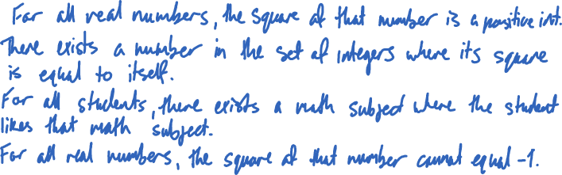

## Negation of Quantifiers

* Consider the statement, “all mathematicians wear glasses.”
* What is the negation of the statement?
* It is natural to think it’s “no mathematician wears glasses,” but that’s not correct.
* The negation is: “there exists a mathematician who does not wear glasses.”
* If just one counterexample can be found, the original statement is false.

### Negation of a Universal Statement

* The negation of the statement:

**∀ x ∈ D, p(x)**

* This is logically equivalent to the statement:

**∀ x ∈ D, ~p(x)**

* Symbolically:

**~(∀ x ∈ D, p(x)) ≡ ∀ x ∈ D, ~p(x)**

Exercise:

Write negations:

1. No computer hacker is over 40
2. **∀** Primes p, p is odd
3. **∀** People x, if x is blonde, then x has blue eyes.

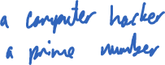

* Consider the statement “some fish breathe air.”
* What is the negation of this statement?
* It is, “no fish breathes air.”
* You might think it should be “some fish do not breathe air,” but this and the original statement can both be true at the same time.

### Negation of Existential Statements

* The negation of the statement:

**∃ x ∈ D ∋ p(x)**

* This is logically equivalent to the statement:

**∃ x ∈ D ∋ ~p(x)**

* Symbolically:

**~(∃ x ∈ D ∋ p(x)) ≡ ∀ x ∈ D ∋ ~p(x)**

Exercise:

Write negations.

1. ∃ A triangle whose sum of angles is 200 degrees.
2. There is a woman who is 120 years old.
3. ∃ x ∈ ℝ ∋ x2 = -1

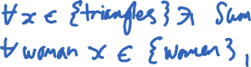

## Summary

* The negation of “all are” is “at least one is not.”
* The negation of “at least one sis” is “all are not.”

Exercise:

Write negations and decide which statements are true.

1. ∃ x ∈ ℝ ∋ 3x = 1
2. **∀** Ɛ ∈ ℝ, **∀** x ∈ ℤ, ∃ y ∈ ℚ ∋ Ɛ > 0 => | x – y | < Ɛ

